LAB ASSIGNMENT – 17

AI for Data Processing
Data Cleaning and Preprocessing Scripts

Course | AI Assisted Coding
Course Code | 25CS002PC304
Academic Year | 2026–2027
Student Name | G.BhanuTeja
Roll Number / Section | 2503a51247

DOCUMENT FORMAT: PROMPT FIRST, FOLLOWED BY VS CODE SCREENSHOT

Task 1: Employee Dataset Cleaning
PROMPT
I am working on Lab Assignment 17 – Task 1: Employee Dataset Cleaning. Write a complete, beginner-friendly Python script using pandas and scikit-learn where appropriate to clean an employee information dataset.
Requirements:
1. Load an employee dataset from a CSV file and display its first rows, shape, column names, data types, and missing-value counts.
2. Handle missing values in salary, designation, and experience. Use median for numeric columns such as salary and experience, and a sensible strategy for the categorical designation column (such as mode or 'unknown'). Explain the choices in comments.
3. Remove duplicate employee IDs, keeping the first valid record.
4. Standardize job titles/designation text to lowercase and remove extra spaces.
5. Encode the categorical features designation and employment_type. Use a suitable encoding method and explain it.
6. Check the cleaned data for remaining missing values and duplicate employee IDs.
7. Save the final cleaned dataset as employee_cleaned.csv.
8. Print a concise before-and-after summary.
Make the code easy to run in VS Code. Include required imports, clear comments, error handling for a missing input file, and a short explanation of each preprocessing step. Do not assume column names that are not present; show how to adapt the column names if my CSV differs.

VS CODE SCREENSHOT
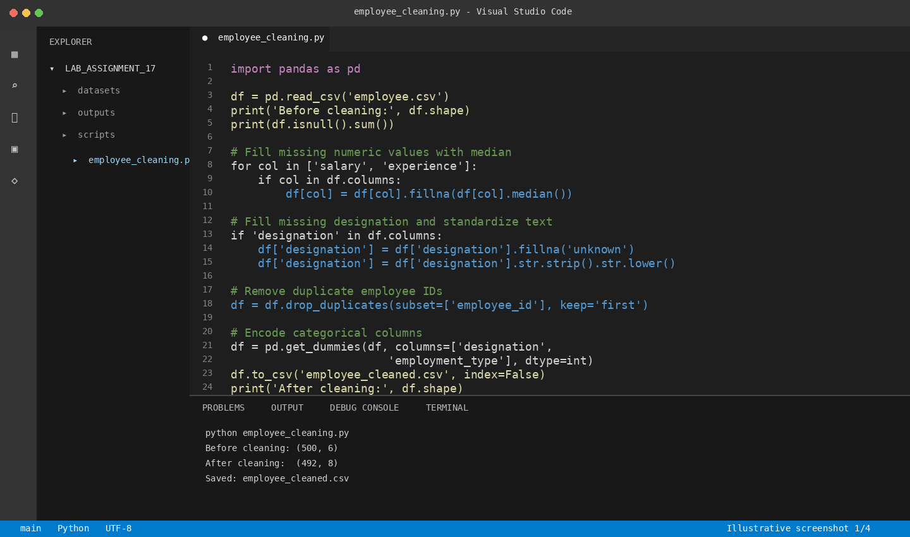
Illustrative VS Code-style code editor and terminal view for this task.

Task 2: Student Performance Data Preprocessing
PROMPT
I am working on Lab Assignment 17 – Task 2: Student Performance Data Preprocessing. Create a complete, beginner-friendly Python script using pandas, NumPy, and scikit-learn to preprocess a student performance CSV dataset.
Requirements:
1. Load the CSV file and inspect the first rows, data types, and missing values.
2. Convert the exam_date column to pandas datetime format, handling invalid dates safely.
3. Extract new features from exam_date: month, semester, and day. Define semester clearly (January–June as Semester 1 and July–December as Semester 2).
4. Normalize total_marks using Min-Max scaling. Preserve the original marks in a separate column if appropriate.
5. Detect outliers in total_marks using the IQR method. Print the lower and upper bounds and the number of outliers. Handle outliers transparently (for example, cap them at the IQR bounds) and explain the selected method.
6. Check the resulting data for invalid dates and missing values.
7. Save the transformed dataset as student_performance_preprocessed.csv.
8. Print a summary of the features created, scaling performed, and outlier treatment.
Write runnable VS Code code with imports, comments, and clear output messages. Do not invent dataset columns beyond those specified; include a note showing how to adjust the file path or column names if needed.

VS CODE SCREENSHOT
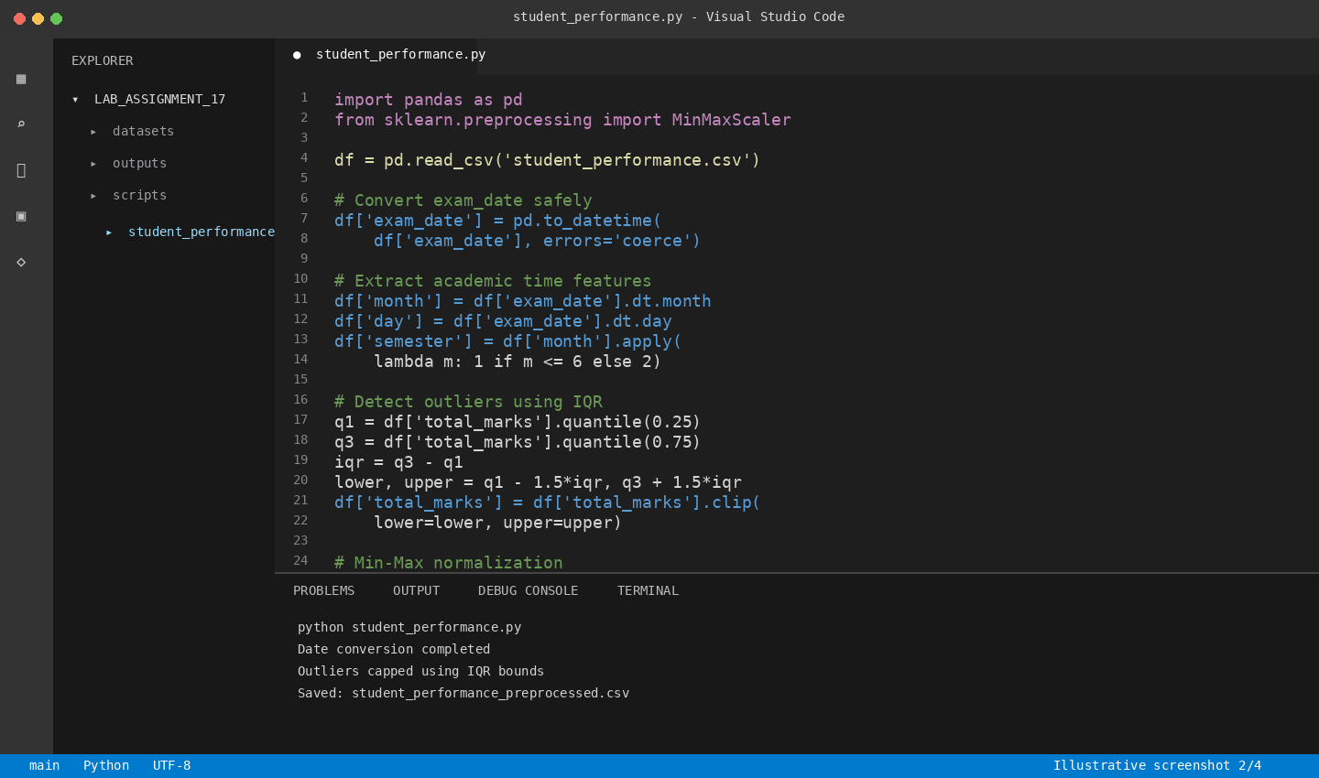
Illustrative VS Code-style code editor and terminal view for this task.

Task 3: Student Health Data Preparation
PROMPT
I am working on Lab Assignment 17 – Task 3: Student Health Data Preparation. Write a complete, beginner-friendly Python script using pandas and scikit-learn to clean and prepare student health records for predictive analysis.
Requirements:
1. Load the student health CSV file and inspect rows, column names, data types, and missing-value counts.
2. Handle missing values in height, weight, and BMI. Use appropriate numeric imputation (median is preferred) and explain the order of operations. If BMI is absent or needs recalculation, clearly state the assumption and use BMI = weight (kg) / height (m)^2 only when the required units are confirmed.
3. Encode the categorical columns medical_condition and fitness_status using a suitable encoding method. Explain the method.
4. Scale numerical features using StandardScaler. Avoid scaling identifier columns or target labels.
5. Split the data into training and testing sets using train_test_split, with a reproducible random_state and a reasonable test size. If a target column is not specified, clearly mark where I must insert its actual name instead of guessing.
6. Prevent data leakage by fitting imputers, encoders, and scalers on training data only where applicable.
7. Save the prepared training and testing datasets as separate CSV files.
8. Print a concise summary of preprocessing and the final train/test shapes.
Provide runnable, well-commented VS Code code, required imports, and clear instructions for changing the input path and target column. Do not make medical conclusions from the dataset.

VS CODE SCREENSHOT
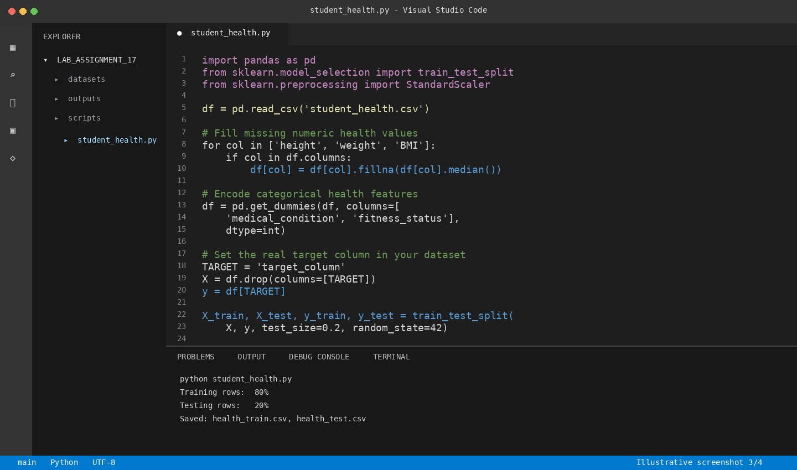
Illustrative VS Code-style code editor and terminal view for this task.

Task 4: Real-Time Application: Ride-Sharing Data Cleaning
PROMPT
I am working on Lab Assignment 17 – Task 4: Real-Time Application – Ride-Sharing Data Cleaning. Create a complete, beginner-friendly Python script using pandas and NumPy to clean a ride-sharing trip dataset.
Requirements:
1. Load the ride-sharing CSV file and inspect its first rows, data types, missing values, and duplicate rows.
2. Standardize pickup and drop locations by trimming leading/trailing spaces, converting text to a consistent case, and normalizing repeated internal spaces.
3. Fill missing fare amounts with the median fare. Handle the case where the fare column contains no valid numeric values.
4. Remove duplicate ride entries. Use a suitable ride identifier if available; otherwise explain and use a clearly stated combination of trip columns without deleting legitimate trips accidentally.
5. Normalize driver ratings to a 0–1 range using Min-Max scaling, while handling missing values and the case where all ratings are equal.
6. Generate a summary of data improvements: rows before and after cleaning, duplicate rows removed, missing fares filled, and rating values processed.
7. Save the cleaned dataset as rides_cleaned.csv.
Write runnable, well-commented Python code for VS Code with all imports, basic error handling, and clear print statements. Do not assume exact column names if the CSV uses different names; include a clearly marked place to map my actual column names.

VS CODE SCREENSHOT
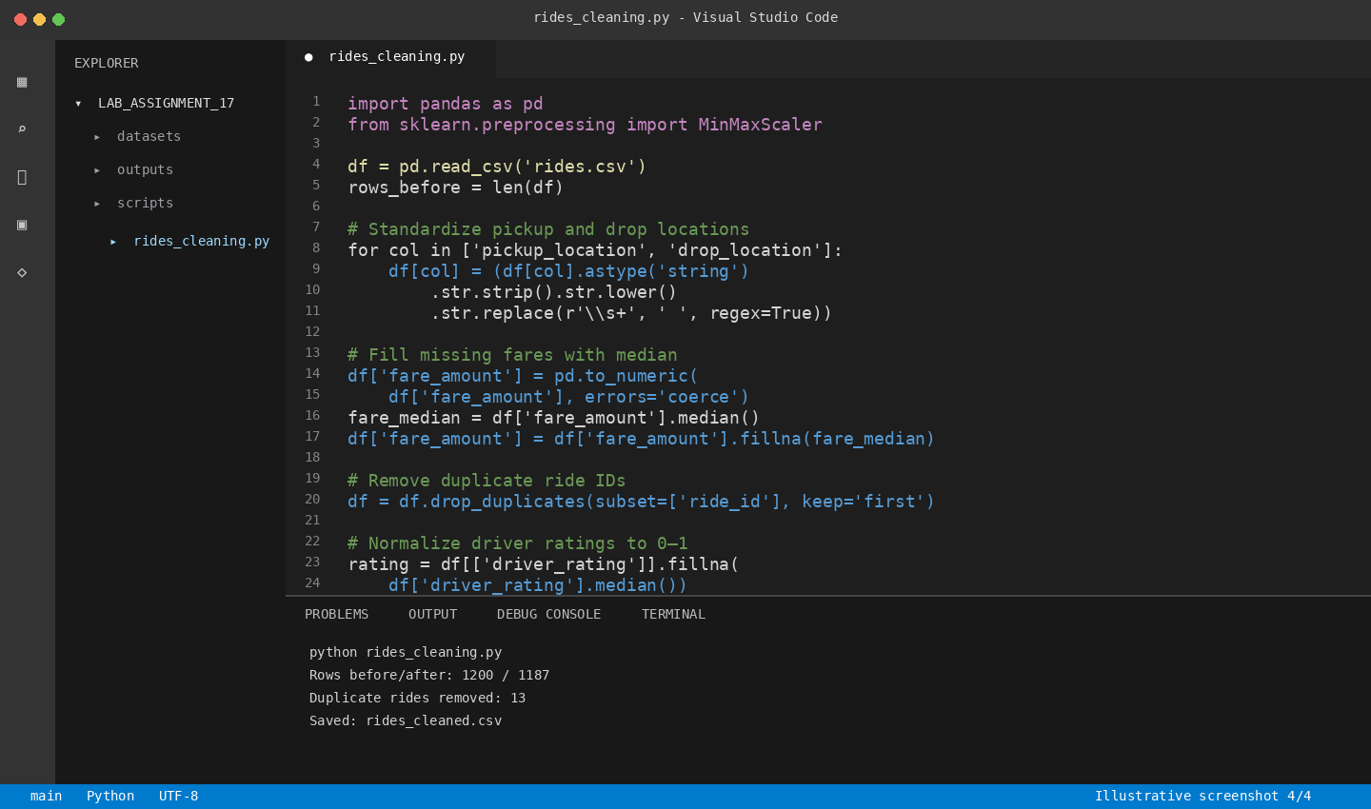
Illustrative VS Code-style code editor and terminal view for this task.

Submission Checklist
- Each task includes the AI prompt used.
- A readable VS Code screenshot is inserted immediately after its prompt.
- Screenshots show the relevant code and/or execution output.
- The input dataset filename and output filename are visible or explained.
- The final cleaned/preprocessed output files are saved separately.
Note: The uploaded assignment requires one Word document containing prompts, comments, code explanation, output, and screenshots where required. No VS Code screenshots were included with the uploaded PDF, so screenshot areas have been provided for you to paste your actual VS Code captures. The prompts above are prepared from the four tasks listed in the assignment.

